Flight Controller v1.0 Assembly Instructions

Bellevue Satellite Club

Written by Dan Ruder, 11/11/2014, revised 2/28/2016

danruder@outlook.com

# Introduction

These instructions will help you correctly assemble the Flight Controller main board. When completing the steps in the Assembly Order section, please refer to Figures 1 and 2 as necessary.

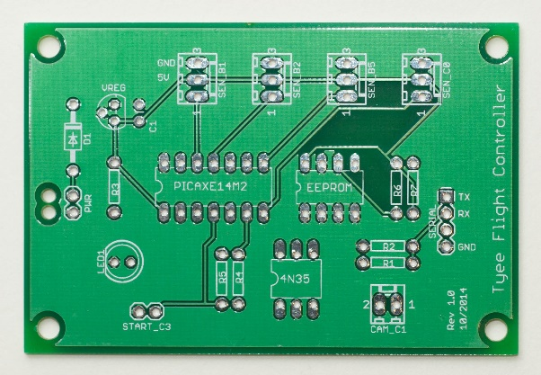

Figure Top view Flight Controller PCB

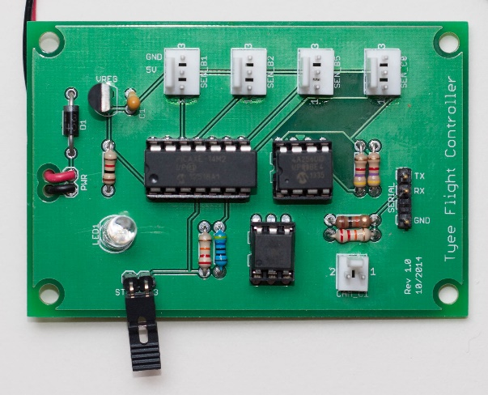

Figure 2 Assembled Flight Controller

# Tools & Materials

Soldering iron

Mini wire cutters

Mini vise or helping hands holder

Lead-free rosin core solder

Masking tape

Super glue or Zap-a-Gap (optional)

All the parts for the board

# General Instructions

* If you are not sure how to solder, please see the [EEVBLOG #183](https://www.youtube.com/watch?v=fYz5nIHH0iY), Soldering Tutorial Part 2 on YouTube.
* When soldering components, work from the inside to the outside, short components to tall components. This will help ensure you have room to solder each component. Solder any components that extend past the edges of the board last so you will have plenty of ways to hold your board in a vise or other circuit board holder.
* Place one or two components on the top side of the board, noting the orientation of each component; then turn the board over and solder these components in place. You may need to temporarily hold the components in place with masking tape.
* Neatness counts! Try to position the components close to the board and pointing straight up when you solder them so they are neat and protected from damage during use. You may need to temporarily hold the components in place with masking tape.
* If you are using lead-free solder, set the soldering iron temperature to approximately 350-375 degrees C. If you are using leaded solder, set the soldering iron temperature to 325-350 degrees C.

**Tip:** to solder a pin, place a little solder on the tip of the iron to promote heat transfer, then place the tip of the iron on the pad and the pin. Apply solder to the pad and pin and it should melt down into the hole, filling the hole and leaving a short volcano-shaped bit of solder around the pin. If you get a round blob of solder around the pin, you have applied too much solder and likely did not heat the pin and the pad.

* Check the solder joins on all of the pins on both sides of the board. If any joint is mal-formed, heat the pad and it should reflow the solder into the hole. Once the joint is correct, clip the leads just above the solder.
* Solder one to a few components at a time so that the leads don’t get in the way when you are soldering.
* When soldering the IC sockets, alternate soldering pins on opposite sides of the socket to give each pin a chance to cool down. This prevents overheating of the board and the plastic IC socket.

# Assembly Procedure

The flight controller board contains six circuits, shown in *Figure 3*, below. You will assemble each of these circuits to complete the flight controller.

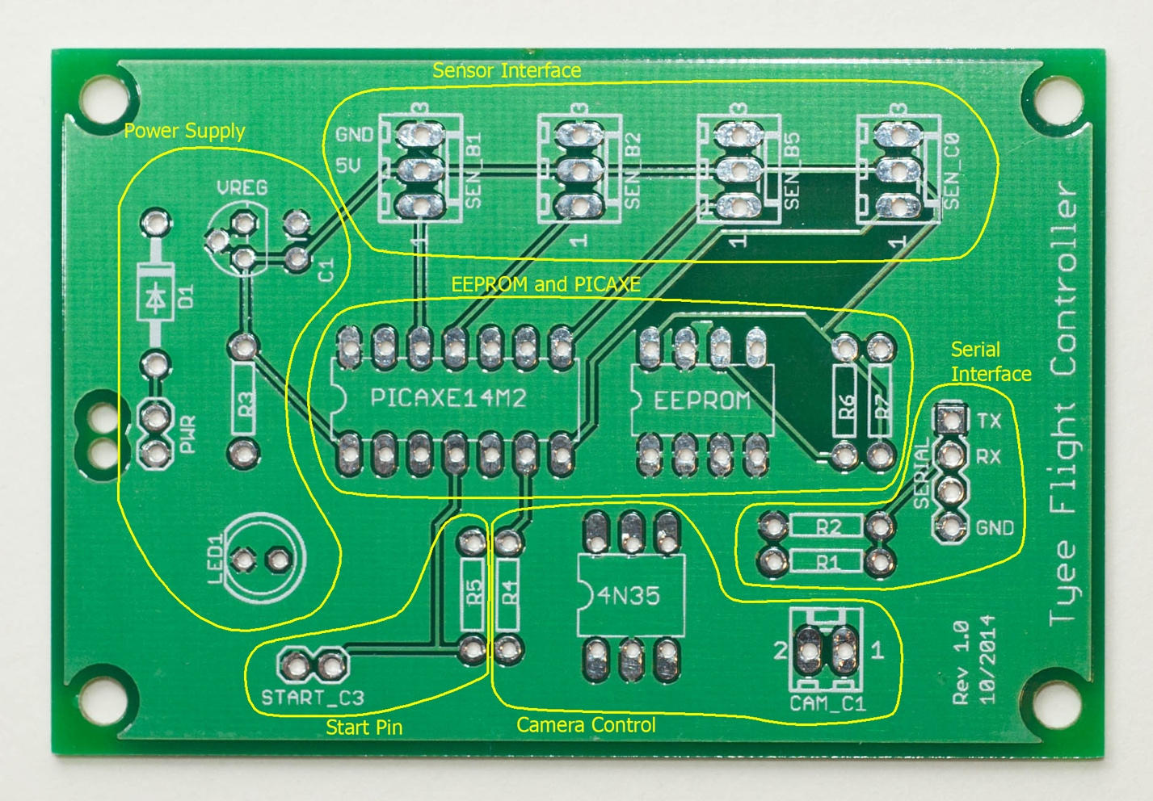

Figure 3 Flight controller circuits

Please be sure to assemble each circuit and each component in the order stated below.

# Power Supply Circuit

1. Solder resistor **R3** (1k ohms, brown-black-red). The orientation does not matter.
2. Solder diode **D1**(1N4004) and be sure to note the orientation. The silver band on the diode must match the white box marked on the board.
3. Solder tantalum capacitor **C1** and be sure to note the orientation. The capacitor is polarized and there is a very small “+” sign on the longer leg. The longer leg with the “+” must be placed in the hole closest to the “C1” label, which is toward the inside of the board.
4. Solder the 3-pin voltage regulator, noting the flat surface of the regulator must match the flat side of the outline printed on the board.
5. Solder the LED (LED1) ; the **short lead should be facing toward the left edge of the board** and the flat part of the base of the LED should match the flat side of the outline printed on the board.

**Do not solder the battery cable now.**

# EEPROM and PICAXE Circuit

1. Solder resistors **R6** and **R7** (4.7K ohms, yellow-purple-red). The orientation does not matter, but if you want to be neat, orient them both in the same direction ☺
2. Solder in the 8-pin IC socket. Be sure to match the notch in the socket to the indentation on the left side of the socket outline. Use masking tape to help hold the socket in place. Solder two pins in opposite corners first, then check the placement of the socket. Once you have verified the placement is good, solder the remaining pins. **Do not insert the IC into the socket at this time. You will do this after testing the flight controller.**
3. Solder the 14-pin IC socket in a similar fashion to the 8-pin IC socket. **Do not insert the IC into the socket at this time. You will do this after testing the flight controller.**

# Serial Interface Circuit

1. Solder resistor **R2** (10K ohms, brown-black-orange). The orientation does not matter.
2. Solder resistor **R1** (22K ohms, red-red-orange). The orientation does not matter.
3. Prepare the 4-pin serial connector by removing one of the inner pins with pliers. Then insert the connector into the board so that the remaining three pins are next to the TX, RX, and GND labels, short sides down, tall sides up. Solder all three pins.

# Camera Control Circuit

1. Solder resistor **R4** (470 ohms, yellow-purple-brown). The orientation does not matter.
2. Solder the 6-pin IC socket in a similar fashion to the 8-pin and 14-pin IC sockets. **Do not insert the IC into the socket at this time**.
3. Insert the white two-pin header into the camera socket marked CAM_C1, noting the orientation in figure 2, at the beginning of this document. Then solder both pins.

Optional: Before soldering the header in place, glue it in place to reduce strain on the pins and pads when removing cables. Do this by applying Zap-a-Gap to the bottom of the header, being careful to avoid the pins. Insert the header and hold it in place for 30 seconds.

# Sensor Interface Circuit

1. Insert the four white three-pin IO headers one at a time, noting the orientation in figure 2, at the beginning of this document. Then solder the pins. Be sure to orient them all the same direction.

Optional: Before soldering each header in place, glue it in place to reduce strain on the pins and pads when removing cables. Do this by applying Zap-a-Gap to the bottom of the header, being careful to avoid the pins. Insert the header and hold it in place for 30 seconds.

# Start Pin Circuit

1. Solder resistor **R5** (22K ohms, red-red-orange). The orientation does not matter.
2. Solder the 2-pin right angle connector to the location marked by START_C3, with the pins facing outward. This connector forms a switch that will enable the mission programs to begin running.

# Battery Cable

1. Push the battery lead wires up from the bottom through the holes on the middle of the left side of the board. The black ground wire must be closer to the LED and the red positive wire must be closer to the diode and the voltage regulator. Push the ends of the wires into the holes with pads and solder them in place. **Be careful not to burn the wires by touching them with any part of the soldering iron.**

**PROCEED WITH THE ELECTRICAL TEST PROCEDURE NOW.**

# Insert the Integrated Circuits (Chips)

**Warning**: Complete this step AFTER the PART 1 tests have been completed and passed.

There are three integrated circuits (ICs) that need to be installed (a 14-pin PICAXE microcontroller, an 8-pin EEPROM memory, and a 6-pin optoisolator); all of them follow a similar procedure:

1. Orient each IC relative to its socket:
   1. The 14-pin PICAXE has an indent; this must match the indent on one of the ends of the socket.
   2. The 8-pin EEPROM has an indent; this must match the indent on one of the ends of the socket.
   3. The 6-pin 4N35 optoisolator has the first pin marked with a small circle, this must be placed on the same end of the socket as the notch

**Warning**: The pins likely will be wider than the socket holes and must be bent carefully to align all pins in the socket holes. You must align the pins to the holes perfectly before you insert the IC or you will damage the IC.

1. If every pin doesn’t sit perfectly in each hole, carefully bend each row of pins slightly by laying the IC on its side on the table and slightly rolling it. Once all pins line up in the socket holes perfectly, gently press the IC into the socket until it snaps or bottoms out. It should be uniformly level in the socket and every pin should be within its hole.
2. Insert the jumper onto the START_C3 pins.

**AFTER THE ICs HAVE BEEN FULLY INSERTED, COMPLETE THE PROGRAMMING TESTING PROCEDURE.**

**CONGRATULATIONS! YOU HAVE FINISHED ASSEMBLING**

**THE FLIGHT CONTROLLER MAIN BOARD!**